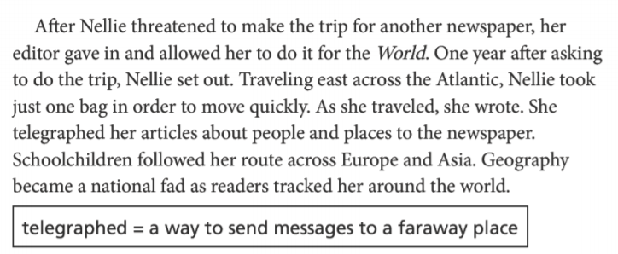
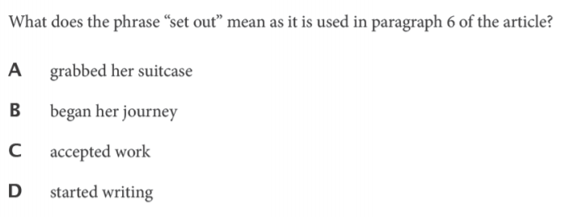
ITEM | RATIONALE for KEY OR MISCONCEPTION
A | Students who choose this answer might misunderstand the phrase “set out” to be synonymous with the action described in the next sentence: “Nellie took just one bag.”
B
C
D

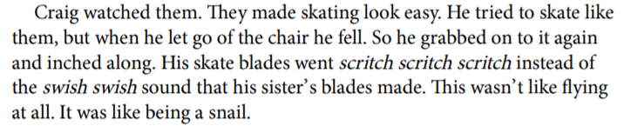

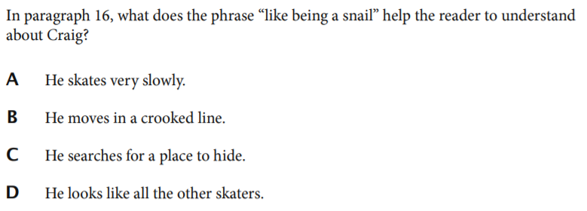

ITEM | RATIONALE for KEY OR MISCONCEPTION
A | This answer choice is the key. Context clues in the paragraph that develop the idea that he skates slowly include the description that he “inched along,” which is synonymous with moving slowly, and “this wasn’t like flying at all,” which suggests the opposite of swiftness.
B
C
D

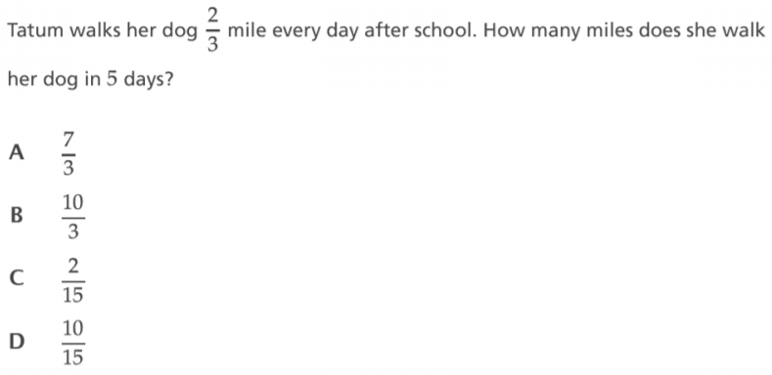

ITEM | RATIONALE for KEY OR MISCONCEPTION
A | Students who choose this answer might mistakenly add the whole number 5 to the numerator 2 to incorrectly arrive at $\frac{7}{3}$.
B
C
D

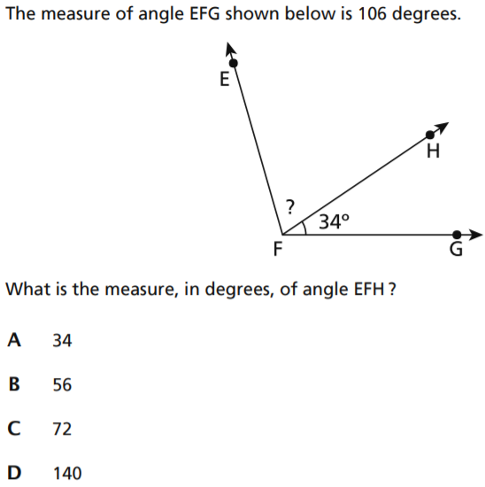

ITEM | RATIONALE for KEY OR MISCONCEPTION
A
B
C | This answer choice is the key. A student arrives at 72 by subtracting 34 from 106. Each angle measure added together results in the total angle measure of 106.
D

